|  |  |  |
| --- | --- | --- |
| **1.** | **Name of the student(S)** | :Madhavan.M  Meha V.S  Nandhini.S  Neeraj.D |
|  | **One valid e-mail id** | :madhavanmadhav114@gmail.com |
| **2.** | **Name of the guide** | : Shobana. M |
|  | **Designation** | :Associate Professor |
|  | **Institutional Address** | :Dept. of Computer Science and Engineering, SNS College of Technology, Coimbatore |
|  | **Mobile No.** | :8248544370 |
| **3.** | **Project Title** | :AI based Drone in Firefighting. |
| **4.** | **Sector in which your Project proposal is to be Considered** | :Engineering and Technology |
| **5.** | **Project Details** | : |

**5.1 INTRODUCTION**

Artificial Intelligence will take care of the issue of drone control, identify item movement using deep learning using thermal camera, and allow the drone to dispense liquid to put out the fire. In order to better rescue efforts and to locate persons trapped within earthquake-damaged structures, firefighters use technology.

**5.2 OBJECTIVES**

The main objective of this project is to help firefighters during fire accidents using drone. Solar panel aids in providing a steady charge and helps to reduce battery drain during emergencies. It enables firefighters to determine whether a person is trapped within the burning building.

**5.3 METHODOLOGY**

We start by constructing several data sets for the drone that will be put on a microprocessor and used for drone motion, drone movement, fire detection, and object detection. The usage of thermal cameras is beneficial at night for detecting fire and moving things. IOT is utilized to deliver signals to fire crews and detect fires.

**5.3.1 Methodology Detailing Stepwise Activities and Sub-Activities**

**Area of Study:**

**Data Collection Tool:** Drone movements datasets, fire identification datasets, and object-identification datasets will all be gathered, and they will be trained using machine learning and deep learning techniques.

**Thermal camera:** To locate the fire's origin and any movement in burning buildings as well as demolished structures, thermal cameras are utilised. It is also utilised at night.

**Object Detection:** It is a tool for quickly and efficiently detecting objects in images using Deep learning. This platform specializes in single object detection, so the quality of the detection results is often accurate and fast.

**Internet of Things:** IOT is used to locate the source of the fire using trained datasets, determine the most efficient route there, and notify the fire fighters of its position if it detects any movement of the object.

**Liquid Extinguisher:** It is connected to the drone that is carrying the fire-extinguishing liquid.

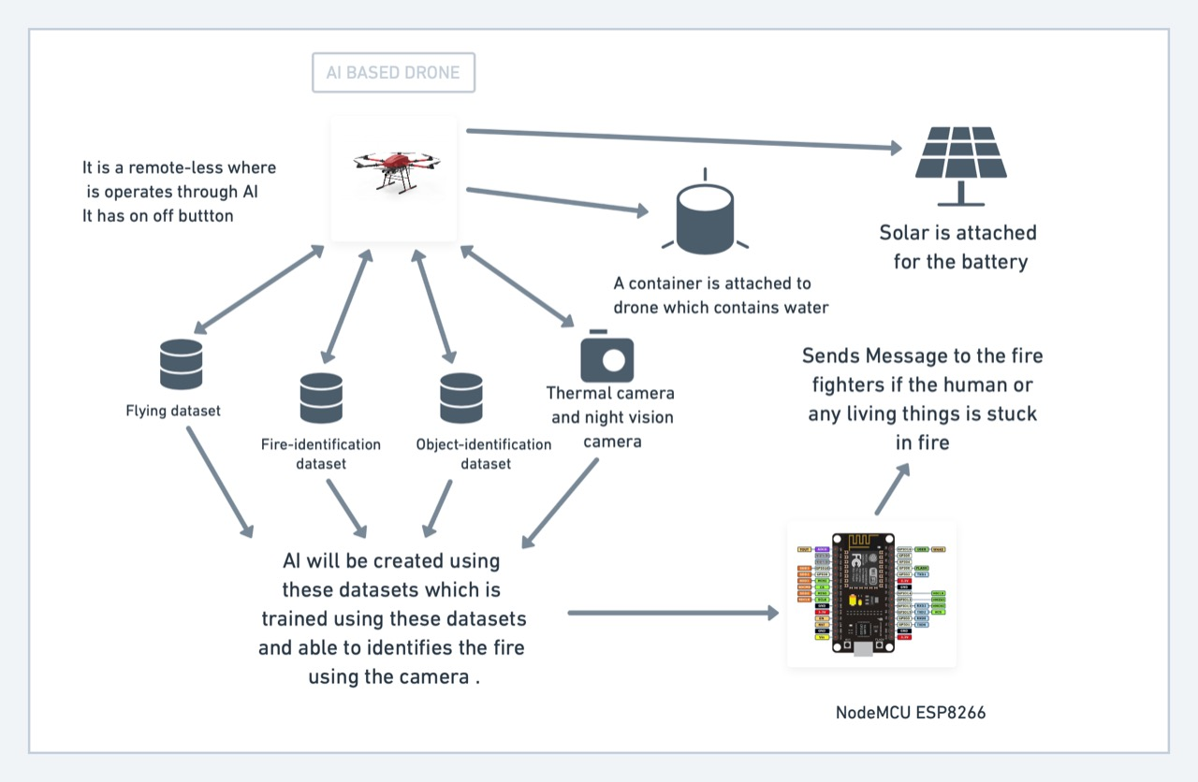

**5.4 WORKPLAN**

|  |  |  |  |  |  |  |  |  |
| --- | --- | --- | --- | --- | --- | --- | --- | --- |
| S.NO | Scheduled of Work | Sep | Oct | Nov | Dec | Jan | Feb | Mar |
| 1 | Literature and Survey |  |  |  |  |  |  |  |
| 2 | Planning and Designing |  |  |  |  |  |  |  |
| 3 | Development |  |  |  |  |  |  |  |
| 4 | Report Preparation |  |  |  |  |  |  |  |

|  |  |  |
| --- | --- | --- |
| S.No | Description | Cost |
| 1 | Drone | 10,000 |
| 2 | Cameras | 10,000 |
| 3 | Solar Panel | 3000 |
| 4 | IOT Boards | 3000 |
| 5 | Containers & Chemical liquids | 3000 |
| 6 | Software | 1000 |
|  | Total | 30,000 |

**5.5 BUDGET**

**5.6 OUTCOME OF THE PROJECT**

It will be simple to identify and save people. Additionally, the source of the fire is found and identified. There will be less manpower.

**CERTIFICATE**

This is to certify that Mr./Miss. is a bonafide final year student of P.G. Science / U.G. Engineering / P.G. professional courses of our college and it is also certified that two copies of utilization certificate and final report along with seminar paper will be sent to the Council after completion of the project by the end of April 2022.

|  |
| --- |
| Signature of the Guide Signature of the HOD Signature of the Principal |
|  |